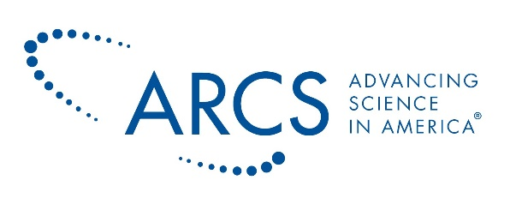

HELPFUL LINKS

- ARCS Website
  - http://www.arcsfoundation.org
- Board of Directors
  - https://www.arcsfoundation.org/about-arcs/governance-partners/national-leadership
- ARCS Alumni Hall of Fame- https://www.arcsfoundation.org/scholars/alumni-hall-fame
- ARCS 2019 Annual Report -
  - https://www.arcsfoundation.org/about-arcs/advancing-science/annual-report-and-financials
- Meir Honor Acknowledged from Space:
  - https://twitter.com/Astro_Jessica/status/1227013028882845696
- ARCS National Twitter: @ARCSFoundation
- ARCS National Facebook: @ARCSFoundation
- ARCS National LinkedIn Page: @ARCS Foundation, Inc.
- ARCS Foundation LinkedIn Group: ARCS Foundation, Inc.
- ARCS National Instagram: @ARCSFoundation

